Case 1: Car off, no headlights

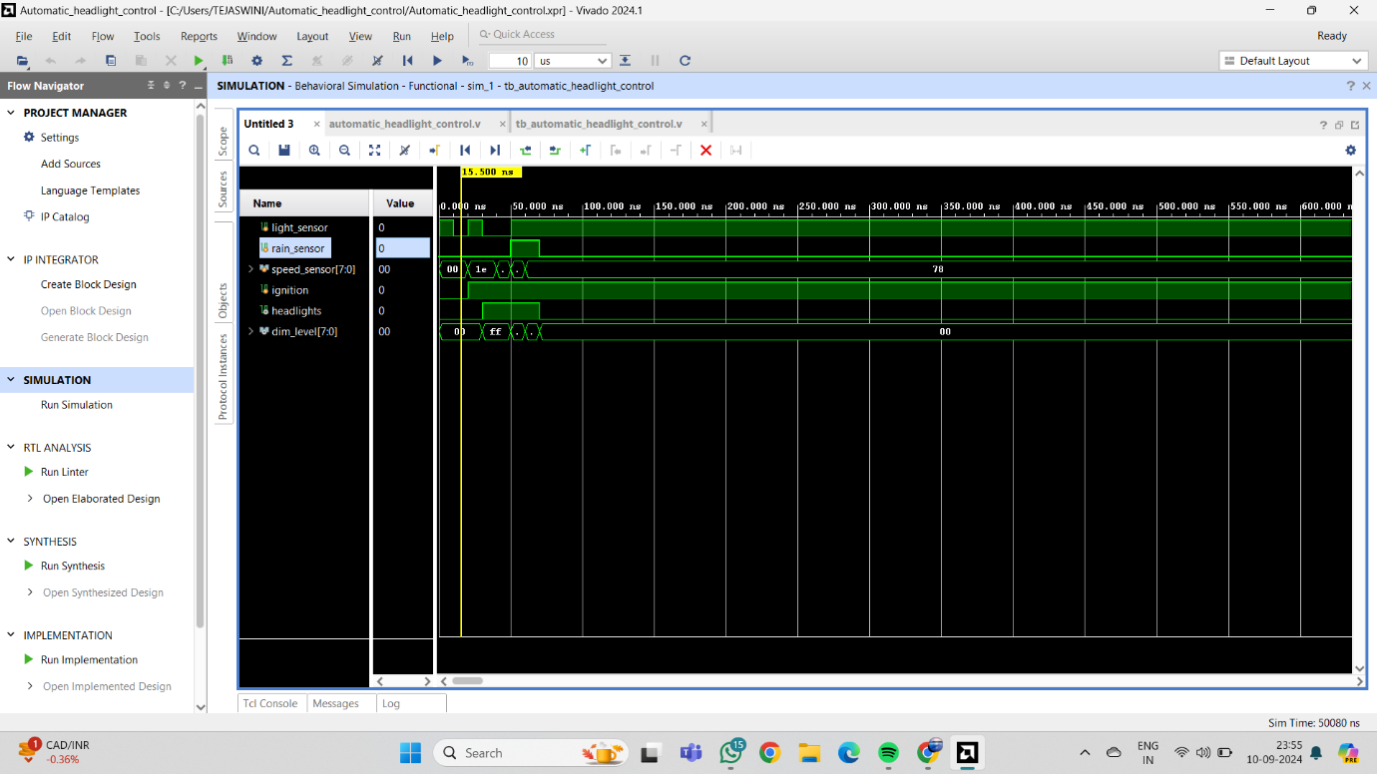

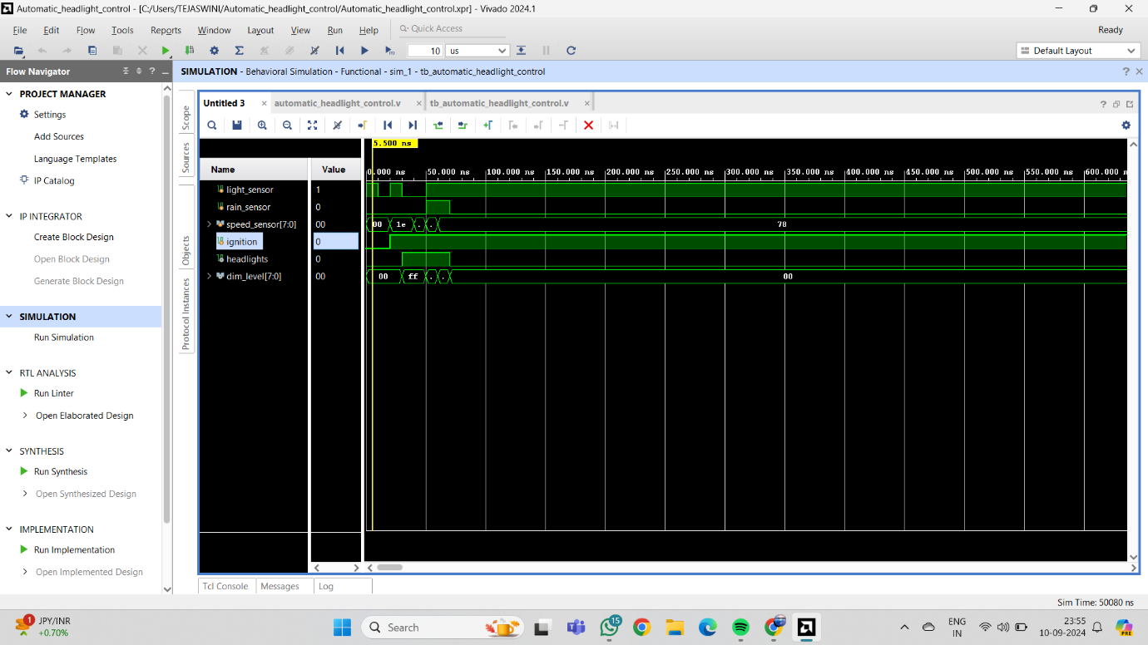

Case 2: Car on, daytime, no rain, low speed

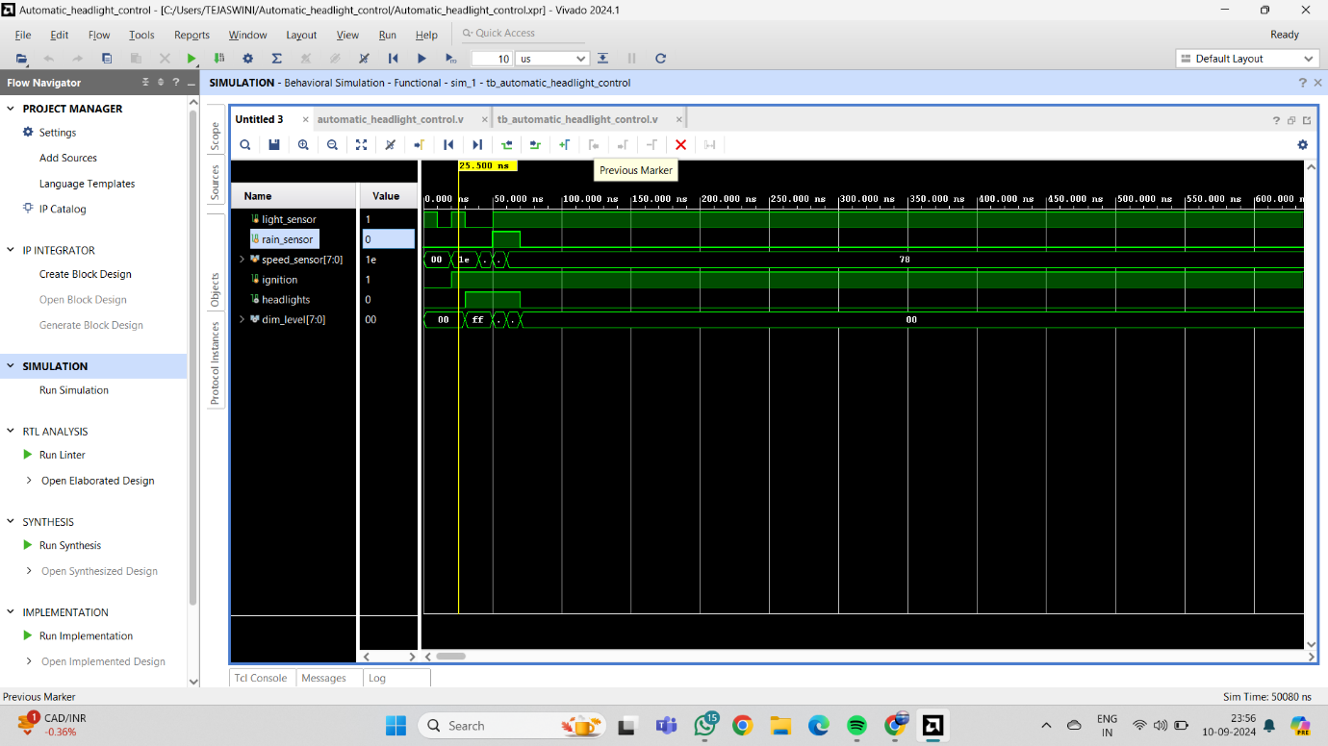

Case 3: Car on, nighttime, no rain, low speed

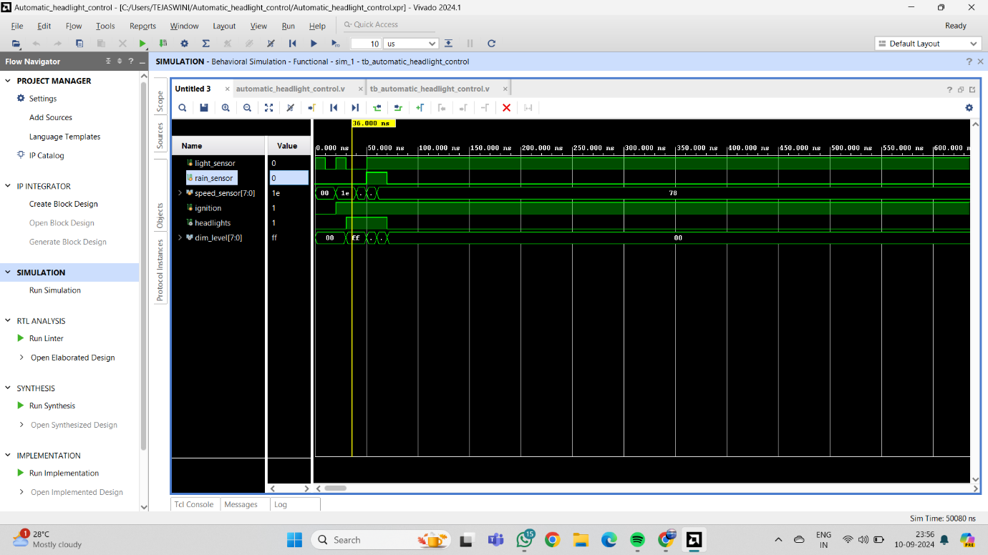

Case 4: Car on, nighttime, no rain, high speed

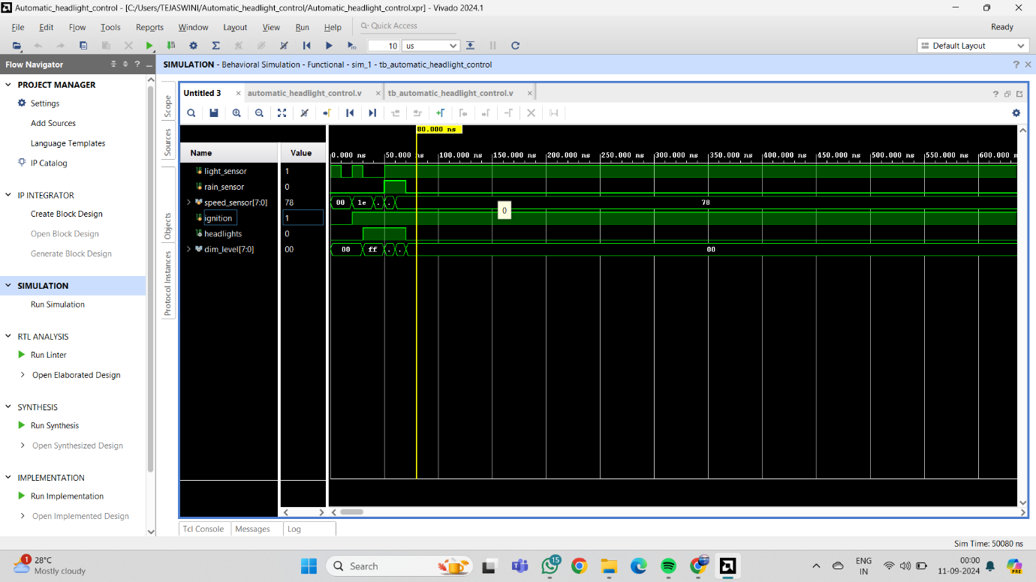

Case 5: Car on, daytime, raining, low speed

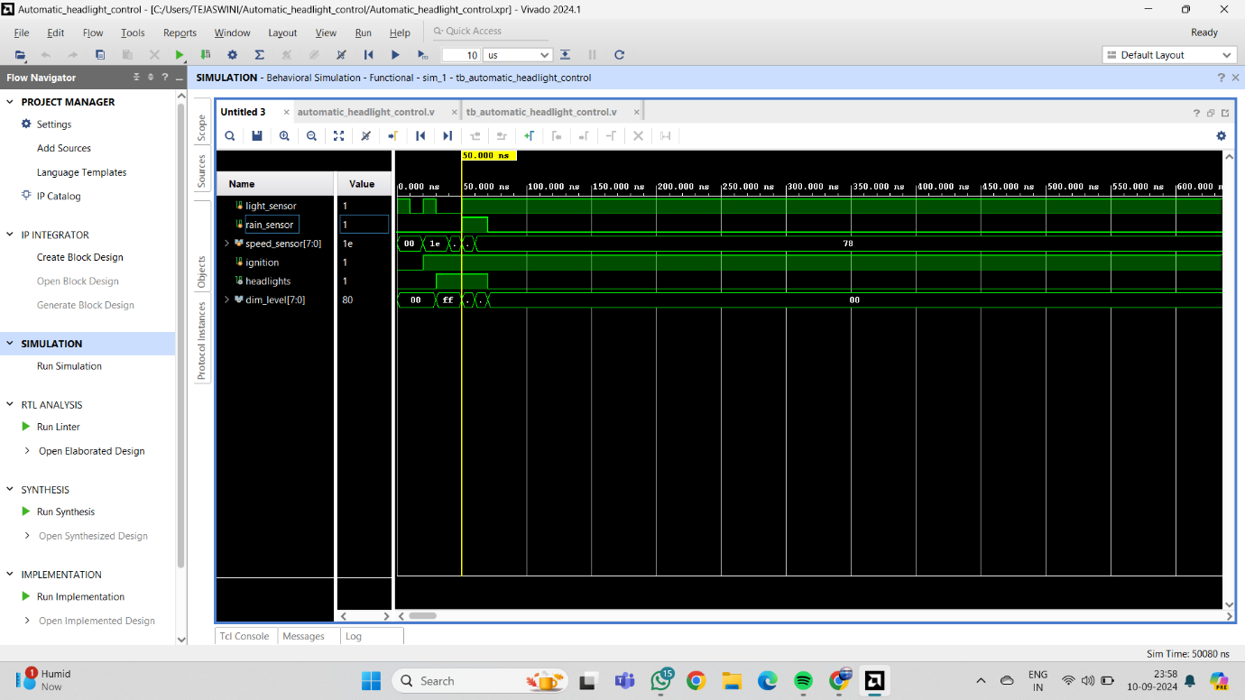

Case 6: Car on, daytime, raining, high speed

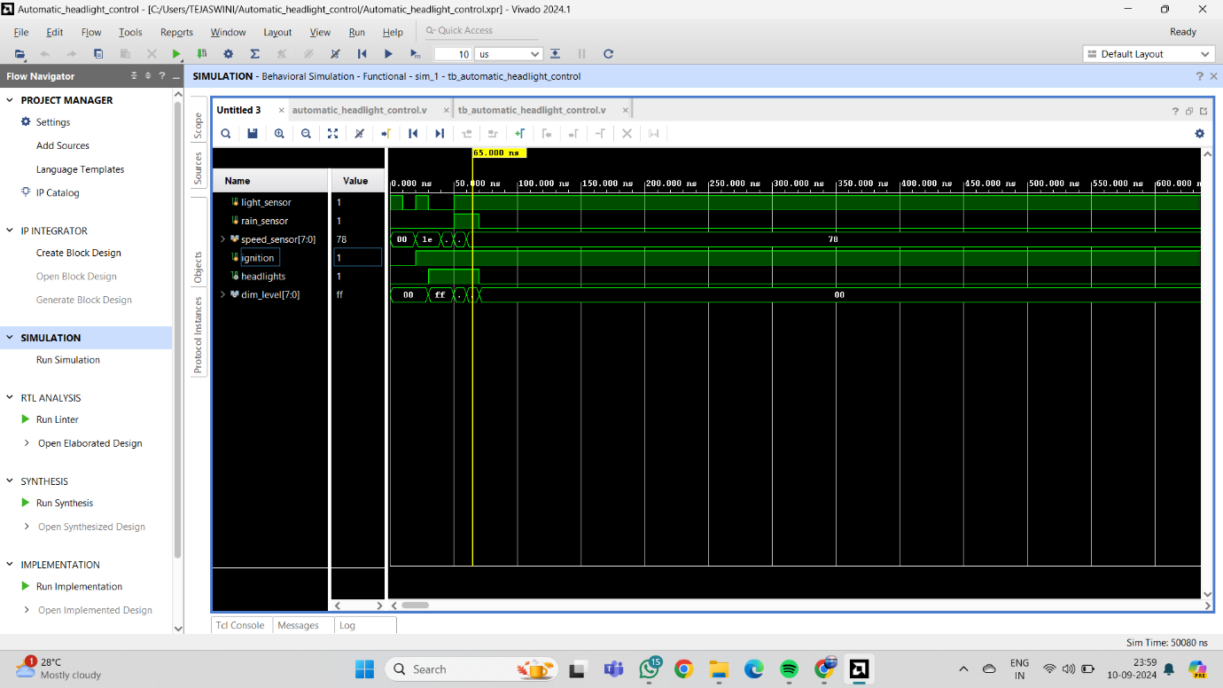

Case 7: Car on, daytime, no rain, high speed

